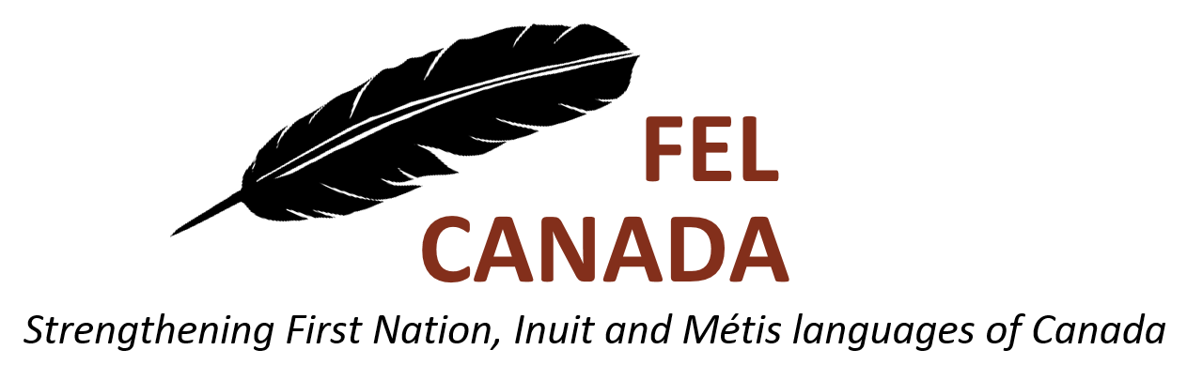

**Instructions**

Send an email with the following information to [felanguagescanada@gmail.com](mailto:felanguagescanada@gmail.com):

* your name, address and telephone number
* an explanation of why you want to attend the conference/symposium and what you hope to gain from the experience
* a short biography

Or you can send the information to:

* FEL Canada, c/o School of Linguistics and Language Studies, Carleton University, 1125 Colonel By Drive, Ottawa, Ontario K1S 5B6

**Submission deadlines**

**April 20, 2019** for Conferences 1 & 2

**Sept. 20, 2019** for Conferences 3 & 4

Four bursaries of $500.00 each are available to support FEL Canada members’ participation in an Indigenous languages conference or symposium held in Canada this year (see list of eligible conferences below). Preference will be given to Indigenous students at a post-secondary institution (full- or part-time) and to applicants presenting a paper or poster, but all participants are encouraged to apply. Only one bursary will be awarded per person.

1. [Stabilizing Indigenous Languages Symposium (SILS)](https://sils2019.com/), Winnipeg, MB, June 6-8, 2019
2. [International Conference on Indigenous Languages](http://www.fpcc.ca/about-us/news-room/news02201902.aspx), Victoria, BC, June 24-26, 2019
3. [First Nations Language Keepers Gathering](https://sicc.sk.ca/first-nations-language-keepers-gathering/), Saskatoon, SK, November 6-7, 2019
4. First Nations Education Steering Committee, [25th Annual Aboriginal Education Conference](http://www.fnesc.ca/conference/), Vancouver, BC, November 28-30, 2019

Applicants must be members of FEL Canada for the year 2019. Membership forms are available at <http://www.felcanada.org> and may be submitted with the bursary application.

We request that bursary award winners contribute a short article (~200 words) for the FEL Canada newsletter about their experience at the conference.

Award winners who are unable to attend the conference will be required to return the funds to FEL Canada.

**2019 BURSARY APPLICATION**

**for an Indigenous languages conference or symposium**